**PRACTICAL NO :6**

Write a program using Selenium WebDriver to select the number of students who have scored more than 60 in all subjects. Perform data extraction and analysis.

* **Input :**

**1st You Create a Excel File**

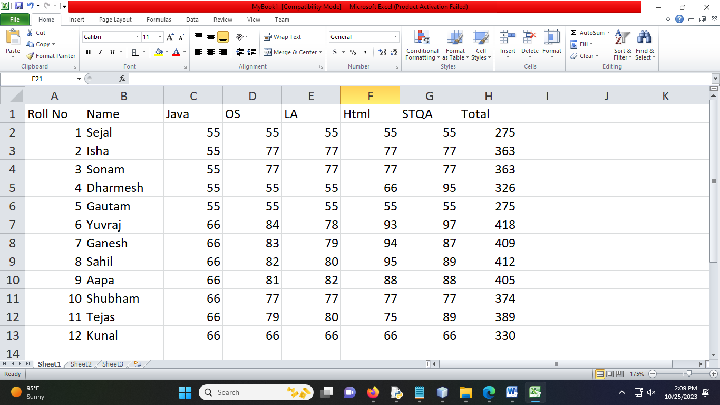

* **Code in NetBeans:**

package pkg60p;

import java.io.FileInputStream;

import java.io.FileNotFoundException;

import java.io.FileOutputStream;

import java.io.IOException;

import jxl.Sheet;

import jxl.Workbook;

import jxl.read.biff.BiffException;

import jxl.write.Label;

import jxl.write.WritableSheet;

import jxl.write.WritableWorkbook;

import jxl.write.WriteException;

/**

*

* @author Sejal Sawant

*/

public class Main {

public static void main(String[] args) throws FileNotFoundException, IOException, BiffException, WriteException {

FileInputStream is = new FileInputStream("D:\\@TYCS\\Software Testing & Quality\\Practical 6\\MyBook1.xls");

Workbook w= Workbook.getWorkbook(is);

Sheet s=w.getSheet(0);

String a[][] = new String[s.getRows()][s.getColumns()];

FileOutputStream os;

os = new FileOutputStream("D:\\@TYCS\\Software Testing & Quality\\Practical 6\\MyBook1Result.xls");

WritableWorkbook wb = Workbook.createWorkbook(os);

WritableSheet ws = wb.createSheet("Result", 0);

int c=0;

for (int i = 0; i < s.getRows(); i++) {

int j = 0;

int intj;

for (intj=0;j<s.getColumns();j++){

if(i >= 1){

String b= new String();

b=s.getCell(2,i).getContents();

int x= Integer.parseInt(b);

if( x < 60){

c++;

break;

} } else {

}

a[i][j] = s.getCell(j, i).getContents();

Label l2 = new Label(j, i-c, a[i][j]);

ws.addCell(l2);

}

}

wb.write();

wb.close();

System.out.println("Students who have scored more than 60 in All subject");

}

}

* **Output :**

